PVC vs Corrugated Pipe: Choosing the best Conveyance for your project

When it comes to choosing a pipe type for a drainage project, contractors tend to defer to what they are comfortable with. “We only use corrugated” or “we only use PVC” is a mantra we at Central hear over and over again. Being tied to a type of pipe is more a function of repetition than it is a function of analyzing what is the best choice for a project. While cost is often the driving factor in deciding on the type of pipe to use on a project, performance, durability, longevity and availability should also be a part of the equation. Below we will examine some of the good and bads when it comes to making an informed decision on choosing the pipe for a drainage project.

Pros and Cons of Flexible Corrugated Pipe
The number one deciding factor in choosing to use corrugated is cost. Rolls of corrugated pipe vs sticks of rigid smooth interior pipe are much less expensive. While for some this is the end all be all in terms of selection, we have to consider all factors when choosing the right pipe. Here are the additional pros for choosing to use flexible corrugated pipe.
Pros of using Corrugated Pipe beside cost:
- Ability to run curves or any shape you would like
- No need for fittings to make turns
- Ability to transport larger quantities in a work truck
Cons of Using Corrugated Pipe:
- Much lower flow rates
- Since the pipe is flexible, water can sit in low spots after rain events
- Have to be more precise to dig a flat and properly pitched trench before installing
- Durability (who hasn’t dug up a corrugated pipe filled with soil and roots?)
- Need to create more pitch in the trench to create positive downhill flow.
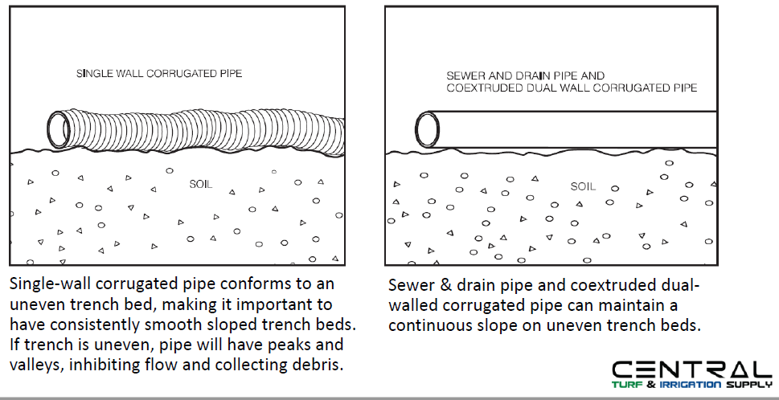

Pros of using Smooth Interior Pipe
- Better flow rates even with less slope
- More durable
- No standing water
- Less forgiving trench excavation
- Longer lasting
Cons of using Smooth Interior Pipe
- Higher cost of both pipe and fittings
- Less can fit into a truck for delivery
- Necessity to use fittings to make every turn

Flow Rates of Flexible vs Smooth Interior Pipes
The first thing to consider is that a flexible pipe will need more pitch than a smooth wall interior pipe. Minimum slopes required are below:

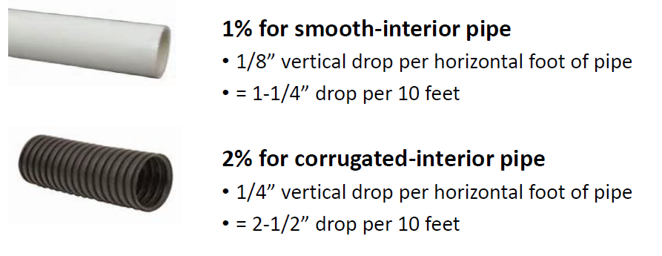
Smooth Interior pipe is especially advantageous when you are working on a site without a lot of pitch. Using smooth wall pipe will save you over a foot of digging over a 100-foot run. Less digging means less labor which is something we all like to see.
The other big advantage of smooth interior wall pipe is very evident when looking at discharge rates. Discharge rate is also explained as the gallons per minute (GPM) a particular pipe is able to move. Referencing the below charts, we will focus on the 4 inch pipe as an example. When installing a 4-inch smooth interior pipe at a 2% slope, we are able to move 157 gallons of water per minute. When compared to corrugated, we are only able to mover 98 gallons of water per minute. For reference, a 4 inch smooth wall pipe at a 1% slope will move more water than a 4 inch corrugated at a 2% slope. See discharge rate tables below for more information on these and other pipe sizes below. The first is for smooth interior wall and the second is for corrugated.
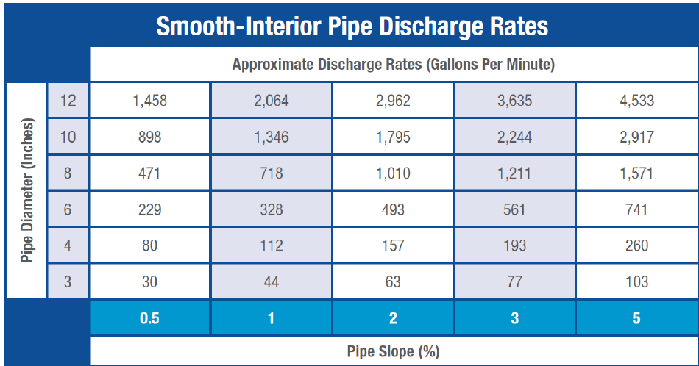

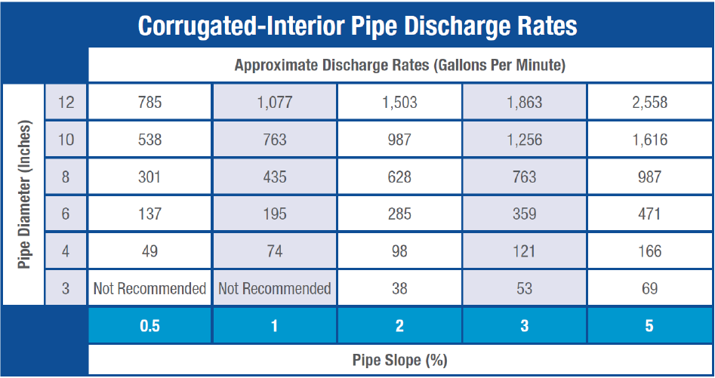

Where Central Can Help
Choosing the right pipe for a project is not always a matter of cost. The right pipe choice can save labor in terms of installation and create a system that performs better, moves more water more efficiently and creates a more durable system you will be able to count on for years to come.

At Central, we carry a wide variety of pipe sizes and types. From coils of flexible corrugated, PVC sdr35, sch40, Dual Wall HDPE smooth Interior to PVC triple wall, we will be able to provide the pipe and fittings you need to insure proper performance. As your drainage partner, we will help you in the making the right decision for your project and then provide the material in competitively priced in stock fashion. Another huge part of the Central Difference is our ability to deliver direct to your shop or jobsite at no cost. Sending crew members off the jobsite to pick up the forgotten items for a project can cost you thousands per year. Let us help you with accurate project-based parts lists as well as stocking your shop with all of the commonly bought items you should never be running out of. In a year where profits will be tougher to come by, having the right material in stock at your shop could make a huge difference in boosting your bottom line.

We understand there is a lot to consider when choosing the right pipe. With knowledgeable account managers and branch personnel, we can make this decision an informed one and you will rest assured you choose the right pipe from your drainage project. Central has the pipe you need along with all the accessories required to complete your project. Please reach out to your local branch or rep to talk over how we can help!

